P101/1740G/21

KAHENI PETER

BIT 440: LOGIC PROGRAMMING

ASSIGNMENT

1.

A. If the query ? – onlychild(y) is executed on the SWI-Prolog prompt, what will be the output? [2 marks]

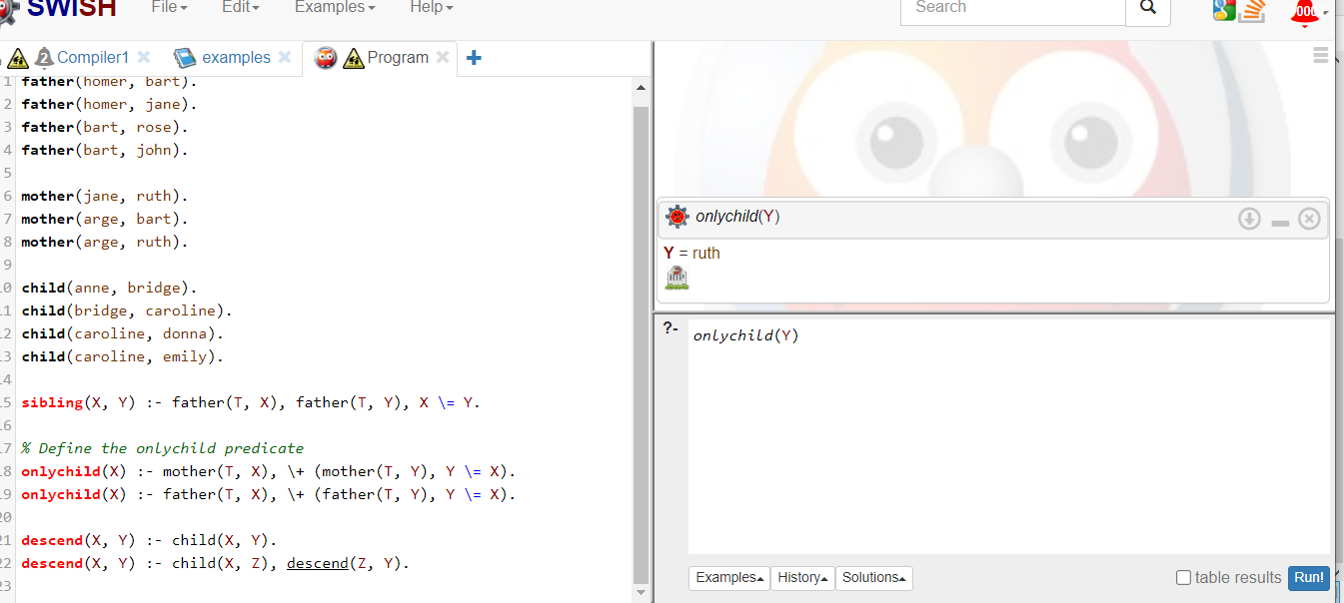

B. If a call to the query ?-descend(X, Y) is made, will it terminate or not? Explain your answer. [3 marks]

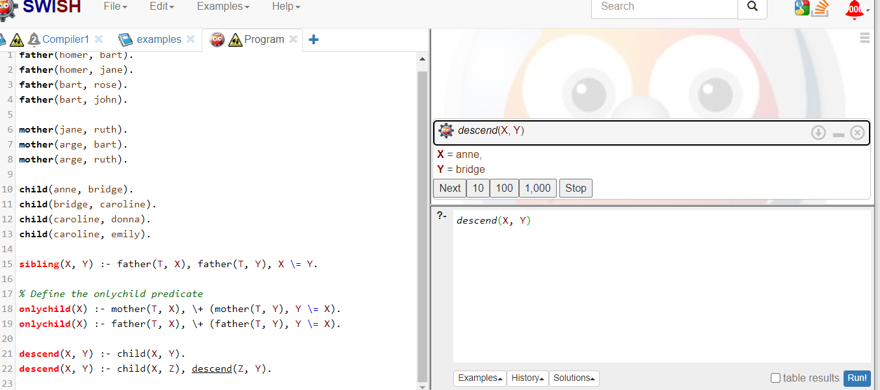

C. Provide a modification for the descend(X, Y) clause so that a call to descend(X, Y) will always terminate. [5 marks]

The modified descend/2 predicate is:

descend(X, Y):- child(X, Y). % Base case

descend(X, Y):- child(X, Z), descend(Z, Y). % Recursive case

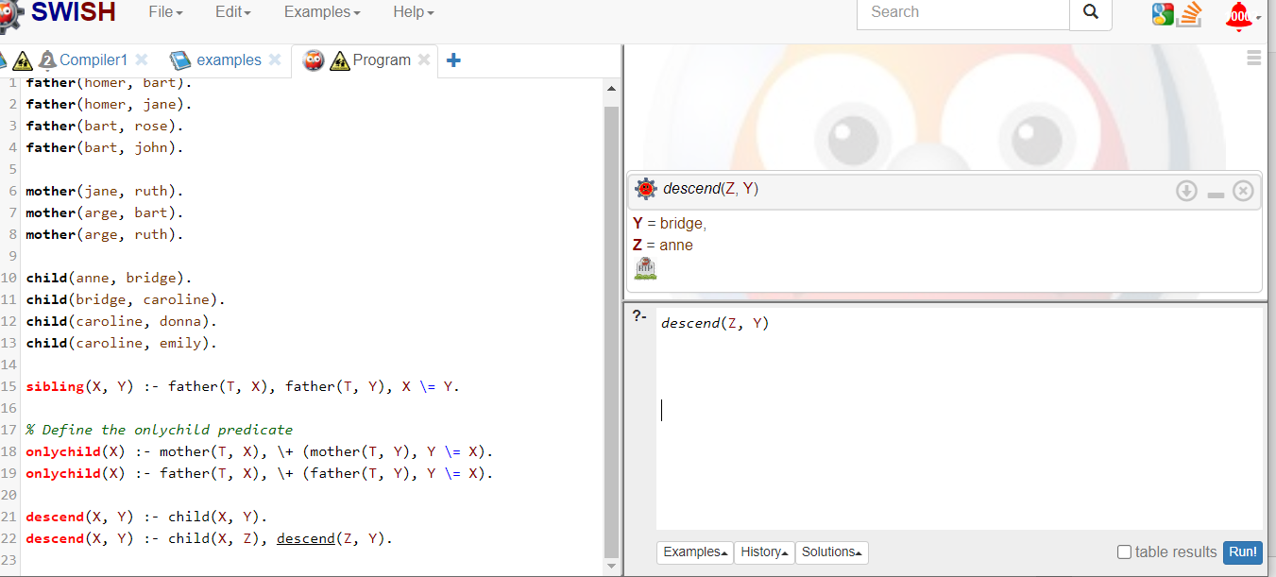

2. State the three factors that may affect the running efficiency of recursive rules in Logic Programming.

A. Recursion Depth: The depth of recursion can significantly impact the efficiency of recursive rules. Deep recursion can lead to increased memory usage and longer execution times, potentially causing performance issues.

B. Recursive Call Optimization: The optimization of recursive calls can affect the efficiency of recursive rules. Poor optimization can lead to increased overhead and slower execution times, reducing the overall performance of the program.

C .Data Structure Used: The data structure used to store and manipulate data can impact the efficiency of recursive rules. Some data structures may be more efficient for certain types of recursive operations, while others may lead to slower performance.

3. Which line(s) would produce errors when the above Prolog program is compiled and explain why. [3 marks]​

* Line 1: Lions (zakayo). - This line contains a syntax error because the parentheses are not properly closed.
* Line 3: tiger(jerry). - This line contains a syntax error because the period should be replaced with a comma.
* Line 10: search(X)-: person(X)),\+(loves - This line contains a syntax error because the closing parenthesis is missing, and the predicate name is not properly defined.